Nick Weimer

October 2019

**Section 1: Dive into Docker**

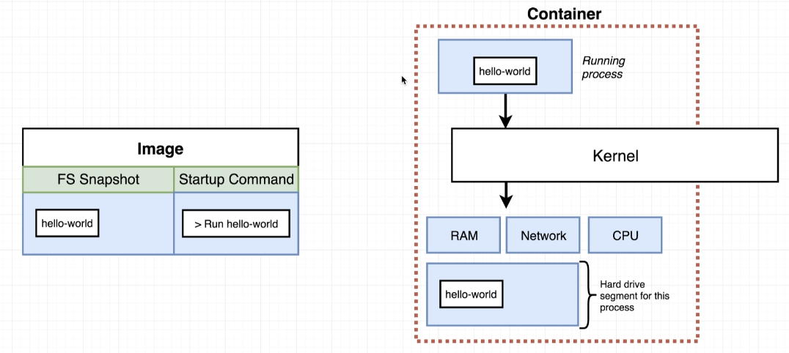

An image has two key things: a filesystem snapshot and a startup command. When that image is instantiated to become a running container, the container will require the startup command to run and it will take that filesystem snapshot as it’s filesystem on its harddrive.

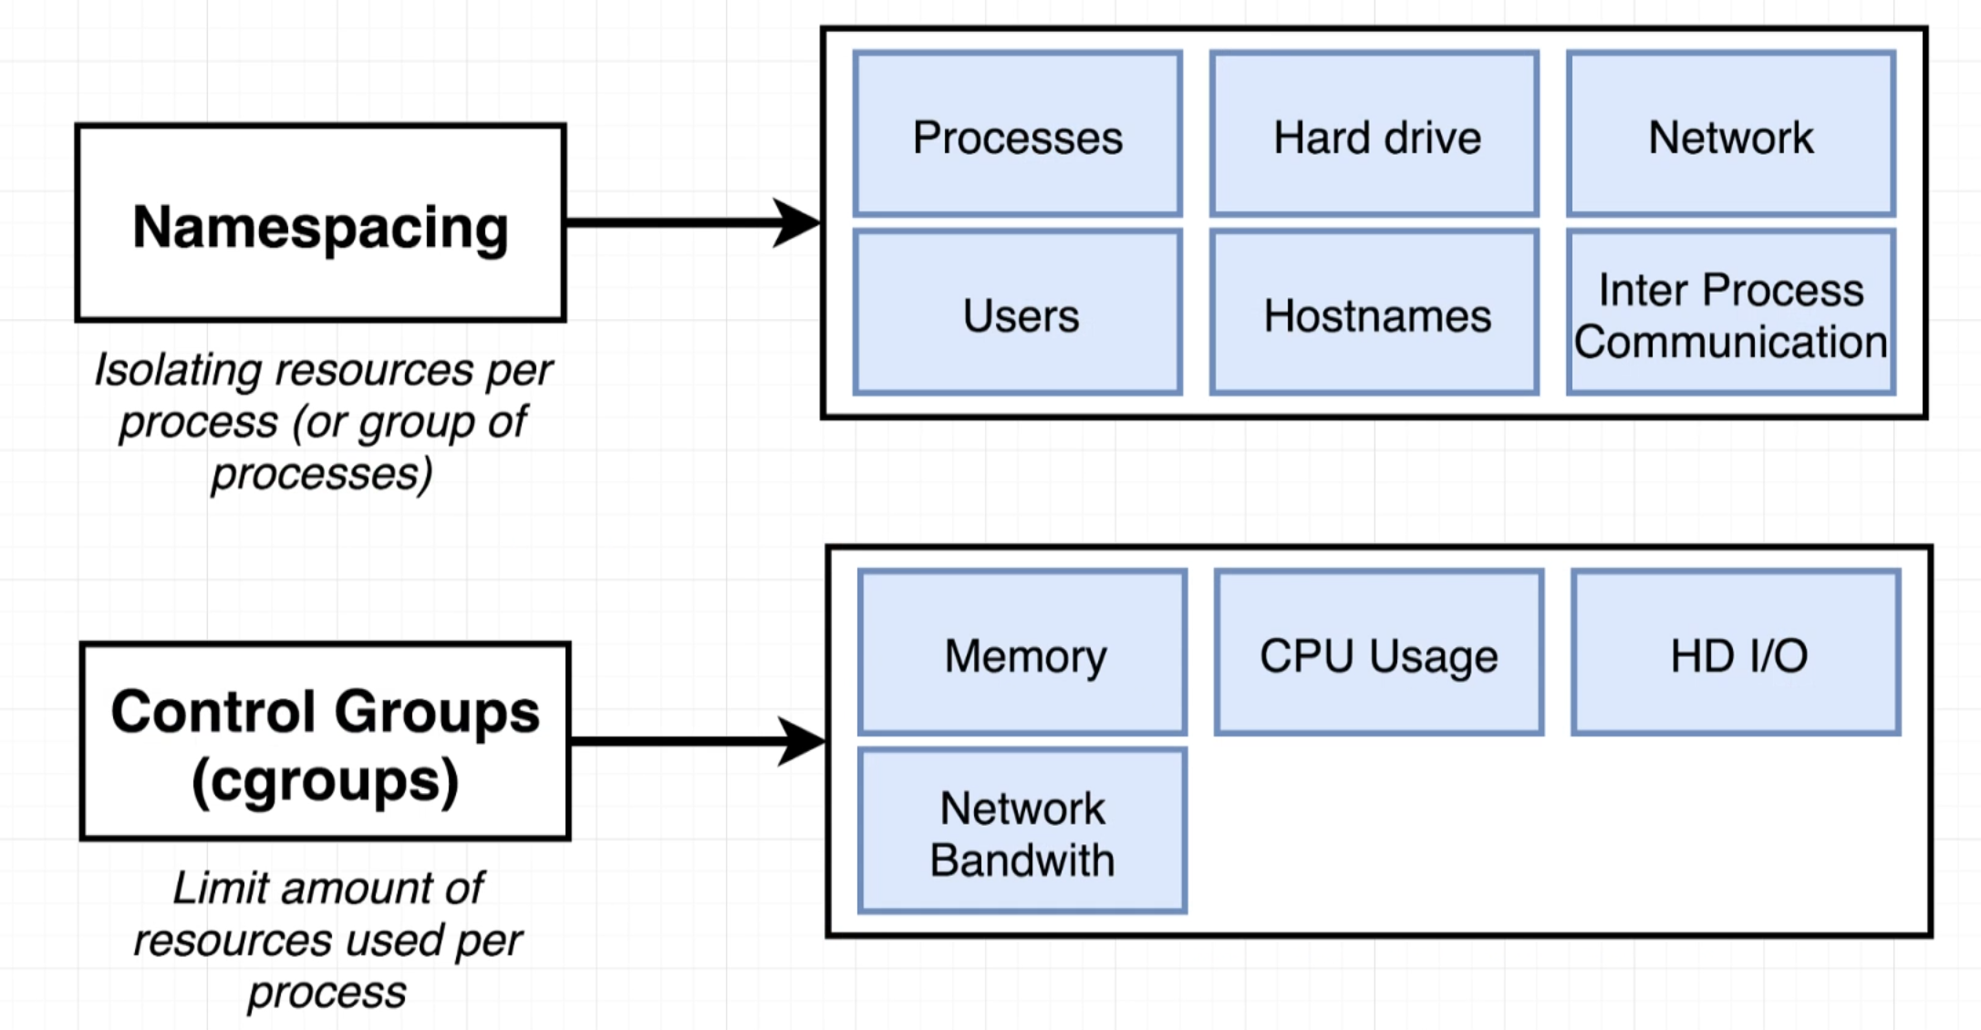

^Namespacing and CGs are specific to the Linux OS. Not on Mac OS or Windows.

When we installed Docker for Windows or Docker for Mac, we installed a Linux VM as well. Inside this VM is where all of the containers will be created.

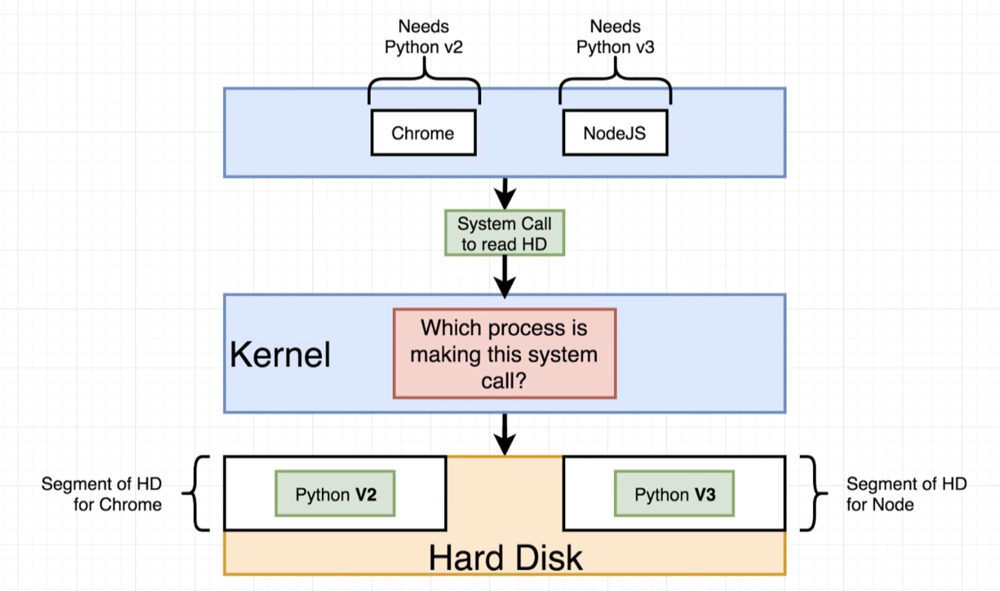

^Chrome and NodeJS don’t actually require these, just an example. Shows that through namespacing the kernel can grab specific sections of the hard disk depending on which process made the call. Namespacing is not only used for hardware, as shown in the previous graphic…it can also be used in networking or seeing other running processes/users etc. Namespacing limits a particular type of resource that a process can use. Control groups limit the amount of resources that process can use such as memory, CPU, etc.

So… A CONTAINER IS A PROCESS THAT HAS A GROUP OF RESOURCES SPECIFICALLY ASSIGNED TO IT.

**Section 2: Manipulating Containers with the Docker Client**

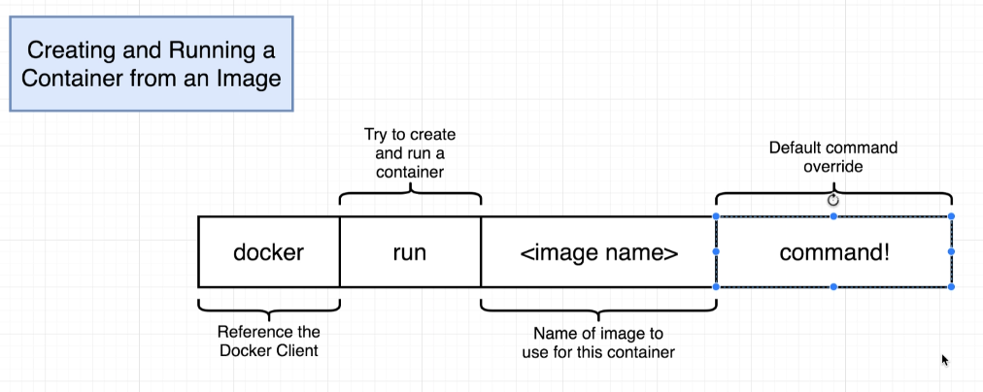

^you can override command the startup command of the image when creating a container. For example:



More useful:

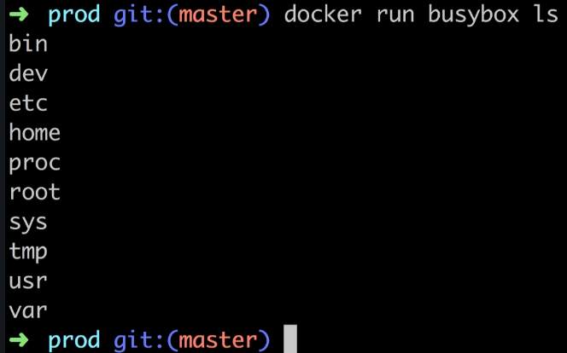

So since we overrode whatever startup command was for this busy box image, this would look like:

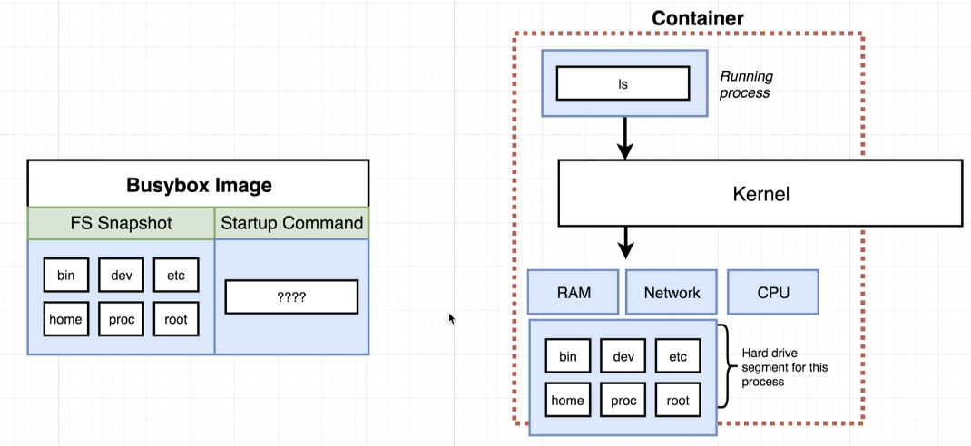

To list all running containers, docker ps (docker ps --all would list all containers, running or not):

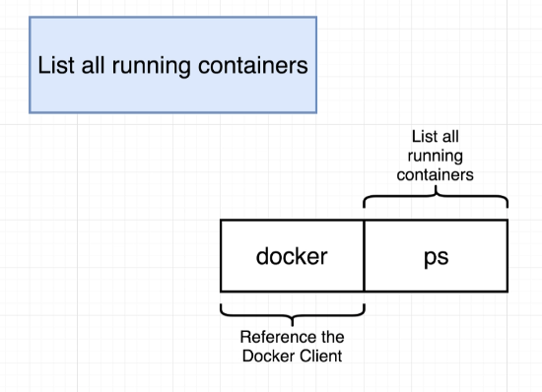

Docker run actually does two things…it creates an image and also starts and image. We can separate these using docker create and docker start instead:

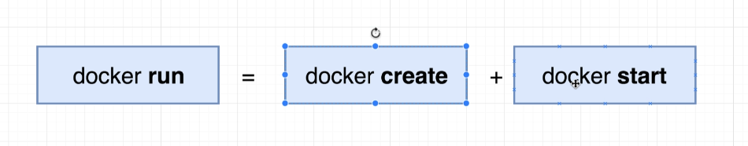

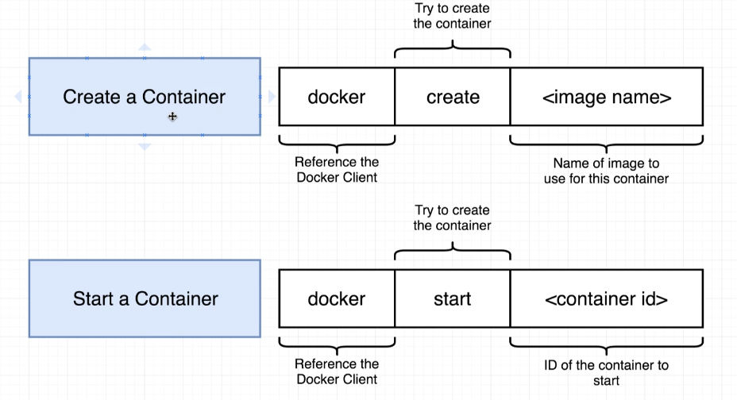

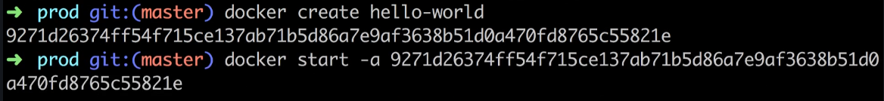

^The -a attaches the output from the container to the terminal

Note: ONCE A CONTAINER IS CREATED, YOU CANNOT REPLACE THE DEFAULT COMMAND. So running docker start -a (the id) echo bye there…this wouldn’t work

To remove stopped containers, docker system prune: 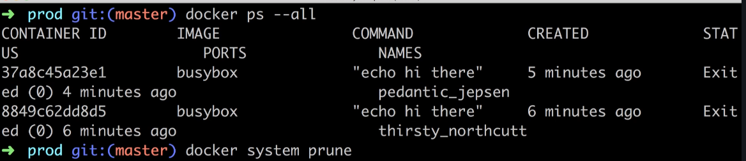

^Note: This removes the build cache. So any images you have cached from docker hub will be removed and it may take a few additional seconds when starting up one of these containers again.

If you don’t include the -a option in the docker start command, it won’t output the result from the container, it will just run it. If we did that and wanted to see the output from the container without running the container again (or if we had ran it some time in the past and don’t want to rerun), we can run docker logs:

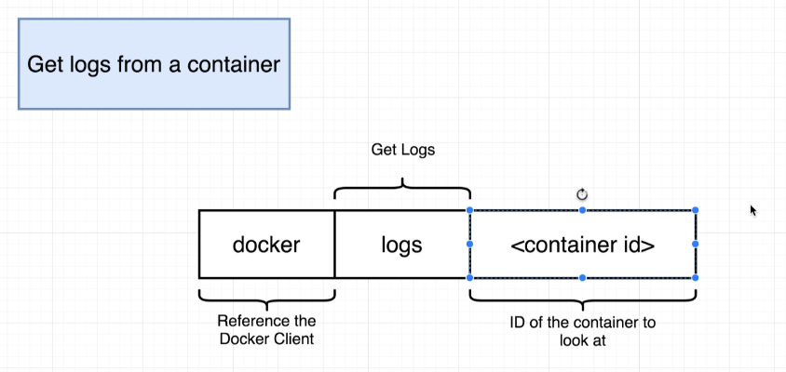

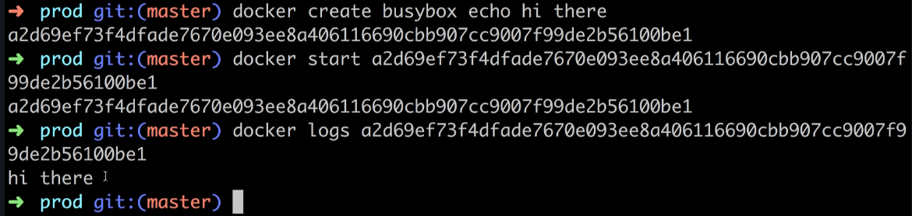

To stop a command:

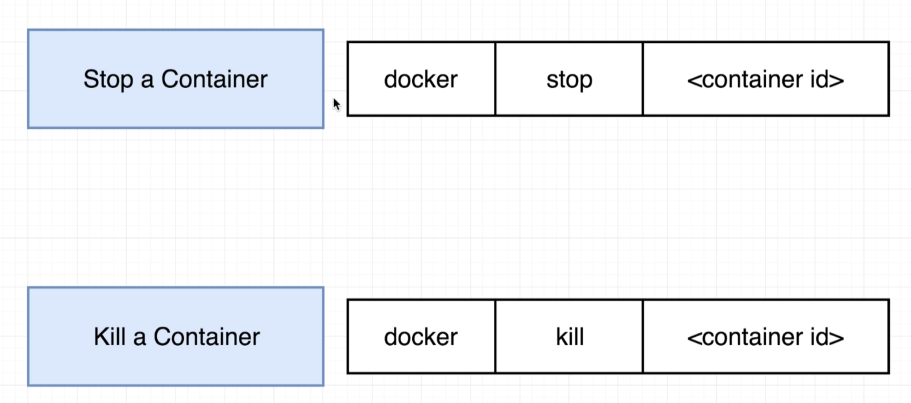

^stop allows process to shut itself down after doing a little bit of clean up. Kill kills it right away. If you use docker stop and it doesn’t stop in 10 seconds, it falls back to docker kill by default.

Executing multiple commands inside of a running container, docker exec:

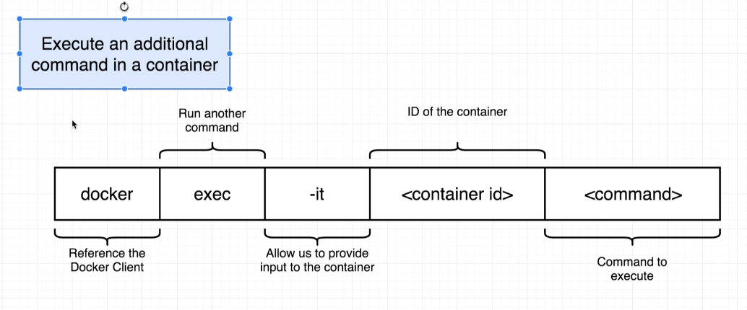

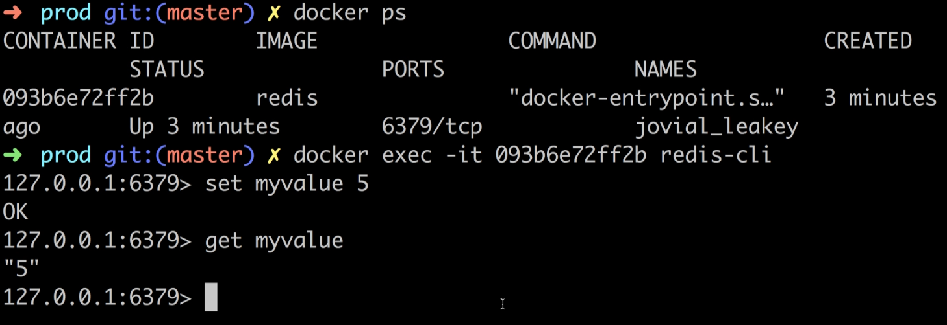

^could also use “it” with docker run if our container is not yet started up. If we run this with “sh” or “bash” as our command (see below), then this will start up that container with an ssh into that terminal, but override any default command that that container is supposed to be running in order for it to run its app. Still useful if you want to poke around the container. But note, the downside is that you won’t be running any other process. It’s probably more common for someone to start up their container with its primary process running (for example, a web server) and then attach to it a running shell by using the docker exec function. Here is a look at docker run with “it”:

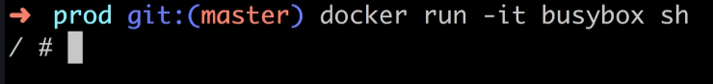

You don’t have to rerun docker exec commands over and over. Instead, you can get shell access to your container with docker exec and sh at the end:

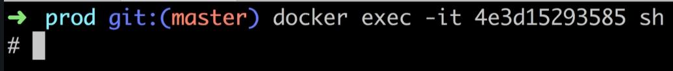

^can use control + c to get out, if that doesn’t work try control + d

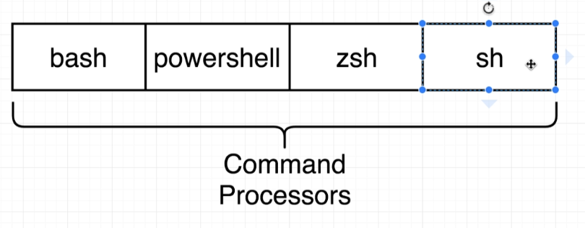

^Some more complete containers/images will have bash

**Section 3: Building Custom Images Through Docker Server**

Up until now, we’ve been using pre-built images from Docker Hub. Let’s learn how to build our own Dockerfile.

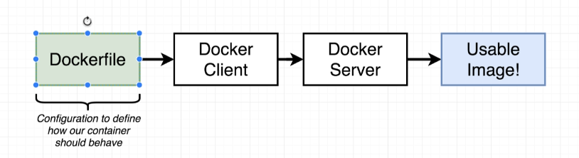

^A Dockerfile is a plain-text file that is going to specify configurations. We use docker client to contact docker server. The docker server is going to do the heavy lifting… it takes the dockerfile and builds a usable image from it.

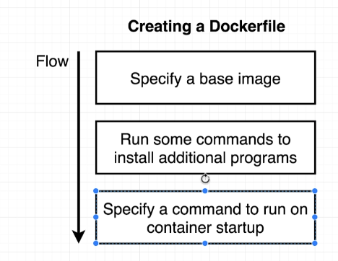

Goal: We will be making a Docker File that creates an image that runs redis-server

In your project directory, create a file called “Dockerfile” (no extension).

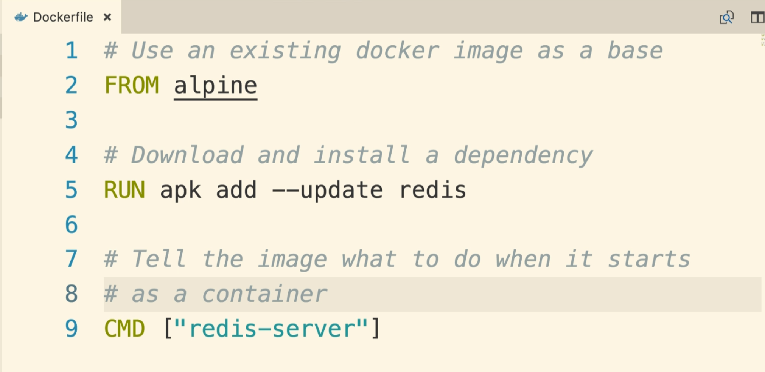

^”FROM”, “RUN”, and “CMD” are known as instructions. There are others. They tell Docker Server how to create the image.

^FROM specifies which docker image to use as a base

^RUN tells docker to execute some command while we are preparing our custom image. Apk is a package manager that is on the alpine operating system

^CMD specifies what should be executed when our image tries to create a container

^Aside from the FROM instruction, each one of these instructions gets run inside their own temporary container or “layer”. The RUN instruction takes the FROM instruction and makes a temporary container out of it in order to run the commands we ask it to, then takes a file system snapshot of the altered container (redis installed to filesystem) so that the next instruction can use that snapshot for its temporary container. So the next command gets runs the snapshot as its temporary container and, since our command is CMD, CMD only sets the Startup Command and doesn’t actually run the startup command on this new container. It sets the startup command (previously there was no startup command set) and takes its own snapshot, which will be the final image for this build.

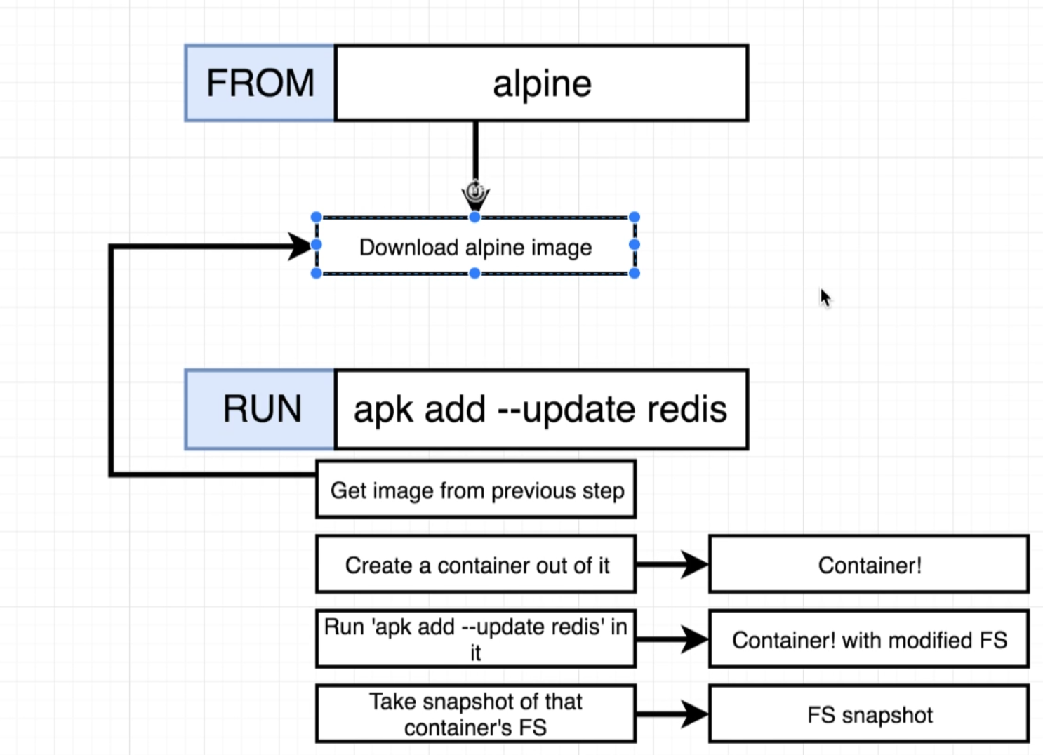

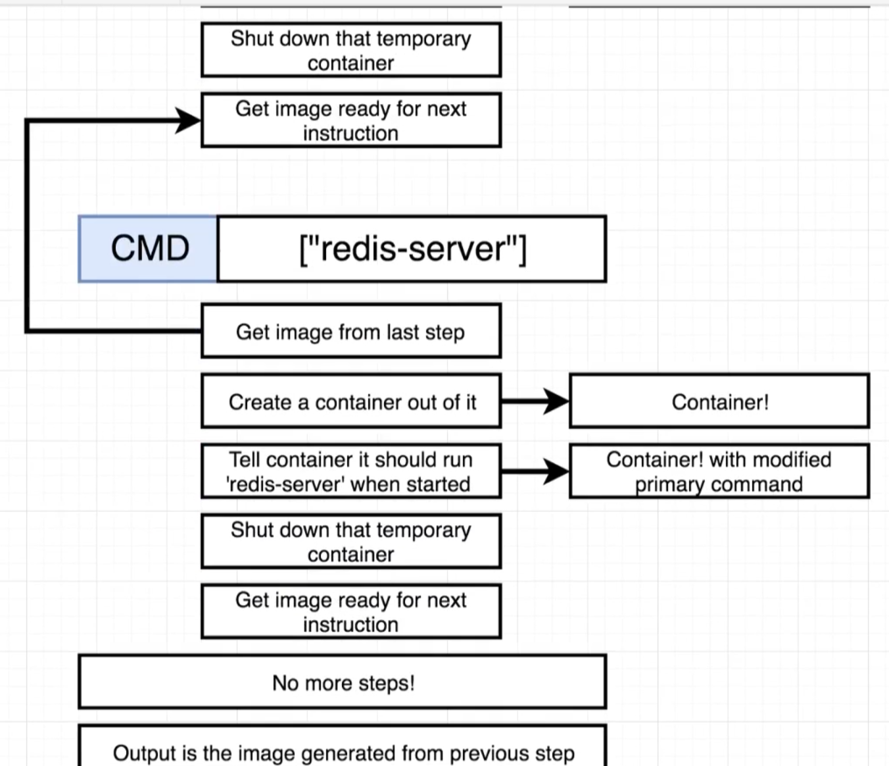

^If we add a command between the 2nd and 3rd instruction here and rebuild, docker is smart enough to use the cached temporary image from the previous build so that it saves time. Also, if we didn’t add any commands and rebuilt, it wouldn’t need to any additional work and just take that cached image.

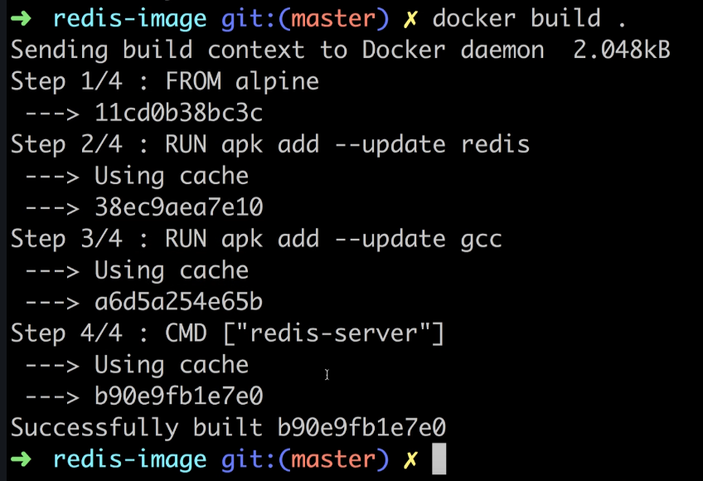

After creating your Dockerfile, go back to command line in your project directory and run “docker build .” …this command gives our dockerfile to the docker cli to build the image. The dot specifies the current directory (I think) which specifies the files and folders that we want to encapsulate in our container.



^Note: At the bottom of this output you can get the container id

Next, run “docker run thecontainerid”



^Note: At the bottom of this output, you should see “ready to accept connections”

You can tag an image so that you could use the tag name instead of container id:

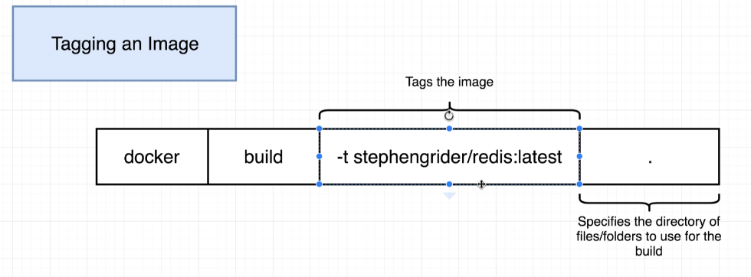

Convention for tag: yourdockerid/projectname:version Note: any time you are creating an image of your own it will be prefixed by your docker id. The images that aren’t prefixed, such as “busybox” are community images.

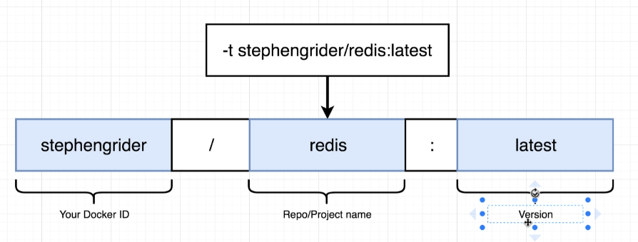

Example:

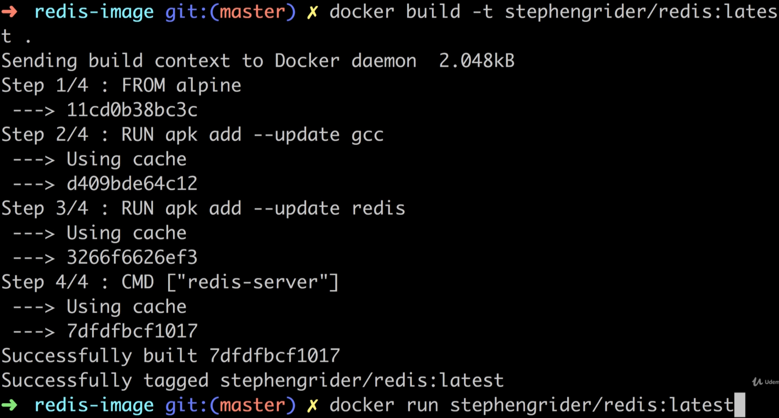

^Note: technically, the tag itself is the version number. Stephengrider/redis is the repository

**Section 4: Making Real Projects with Docker**

New project: Make a tiny Node.js web app inside a docker container and be able to access that app from a browser on our local machine.

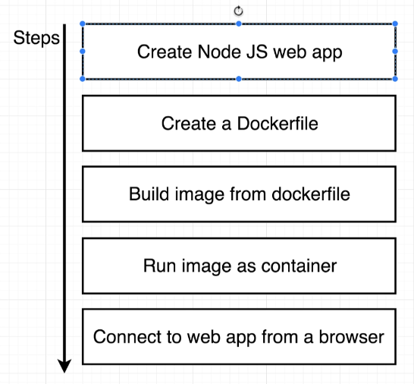

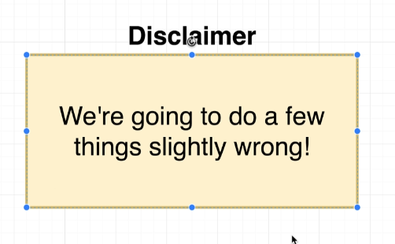

Doing some things purposefully (will be explicitly mentioned) wrong when making dockerfile.

He has an index.js file and a package.json file in a directory:

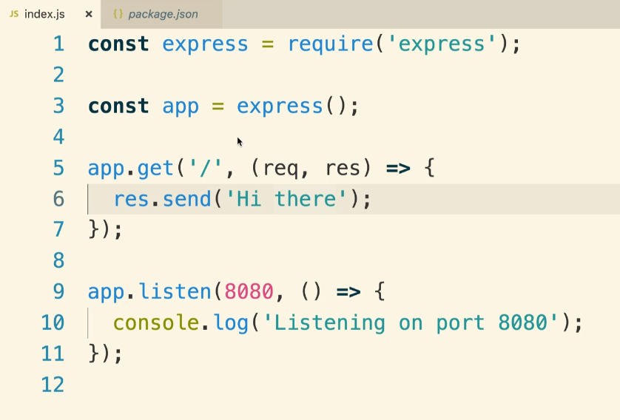

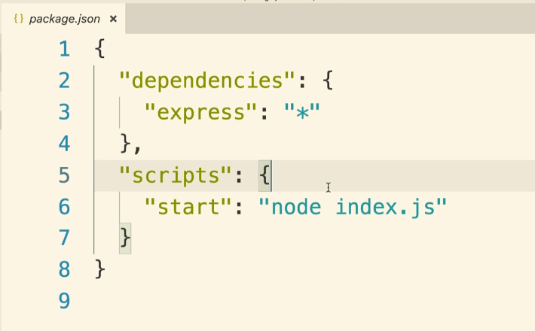

A quick note about node js apps:

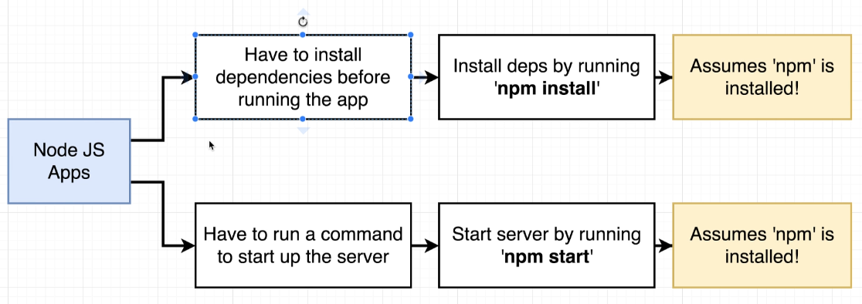

^npm start will run node index.js as defined in package.json

Here’s how it compares to before:

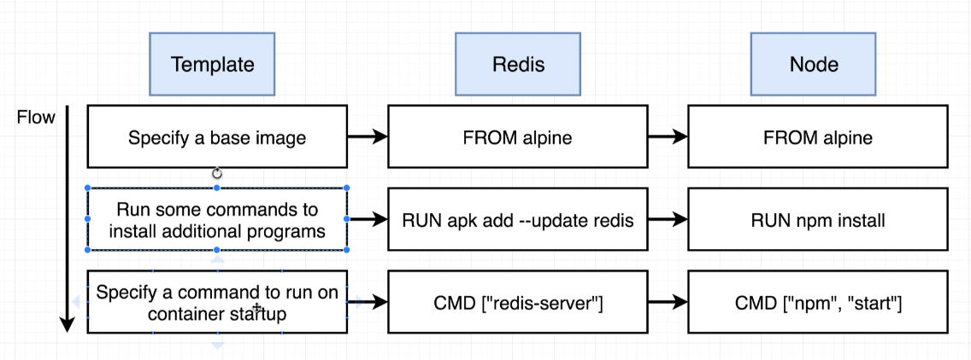

Let’s create our Dockerfile.

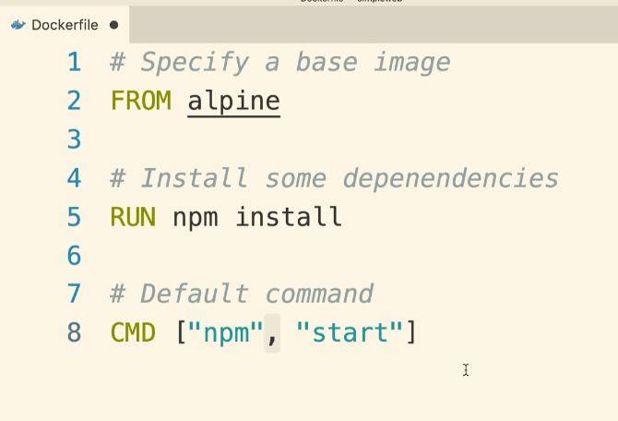

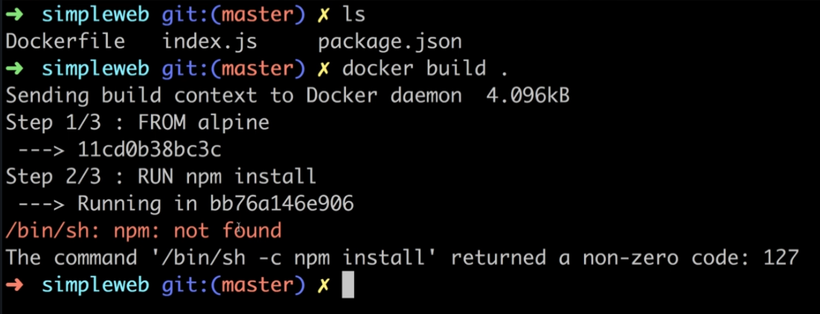

^But the build doesn’t work! Why? Because there was no npm available in alpine. Alpine is a very small image (~5MB) and doesn’t include npm. Instead, we can use another image or run an instruction that downloads npm to our alpine image. We will use the node image instead. Can search community images on hub.docker.com and clicking “Explore” tab

You can specify versions if you need to by using :versionnumber in your FROM instruction (check the docker hub description for the image you are using to see if/what versions are supported):

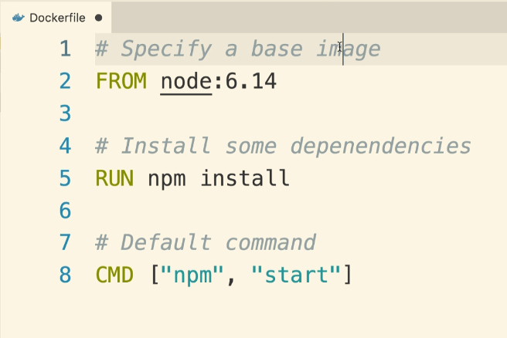

He noticed from the node image description on docker hub that we could also install the alpine version of node. What is the purpose of alpine being tied onto node? Alpine is a term in the docker world for an image that is as small as possible. Many popular repos will offer alpine versions of their image. The alpine version of node means you will not get a bunch of pre-installed programs like Git, or different package managers, or maybe some fancy text editing tools…it will just be the most stripped down version as possible. It will still likely have ls command, cat command, a text editor, ping command, and other basics.

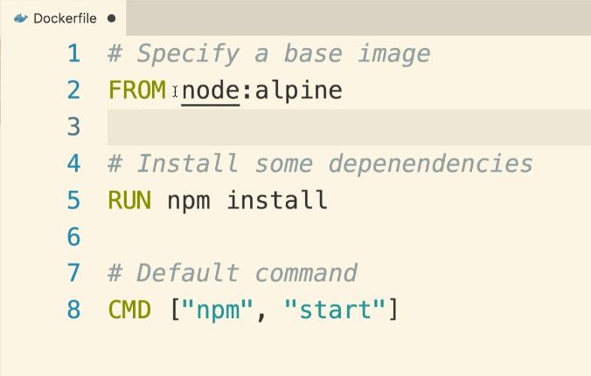

^He ran this using “docker build .” and it gave an error that it didn’t have access to a package.json file even though package.json was defined in the same directory as this dockerfile. We have npm but it can’t find package.json on the temporary container’s filesystem. We have to add in a line of configuration with the COPY instruction (before the RUN npm install instruction) to allow this container to access package.json and index.js:

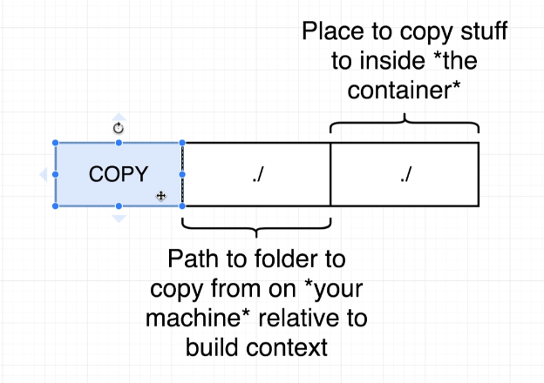

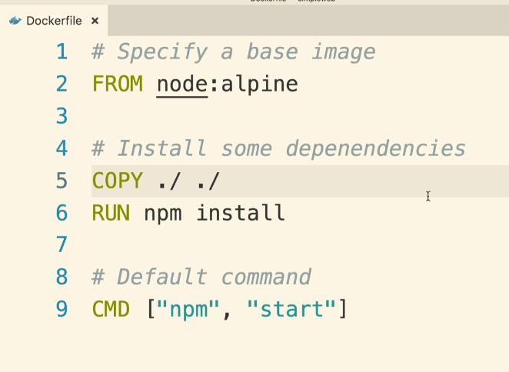

^Running docker build . for this dockerfile worked! If you don’t tag it, it gives an npm notice and 3 npm WARN signals but these can be safely ignored.

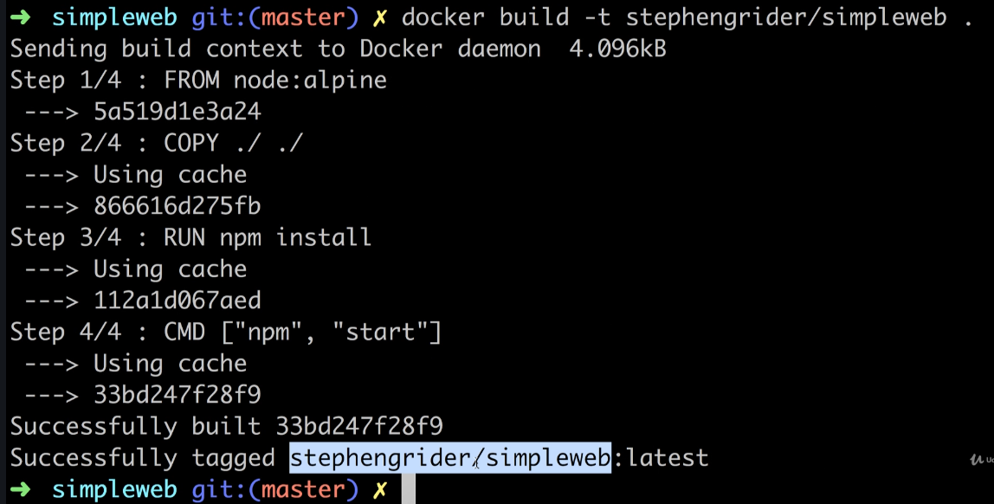

Next, let’s try to start up the container from this image using docker run:

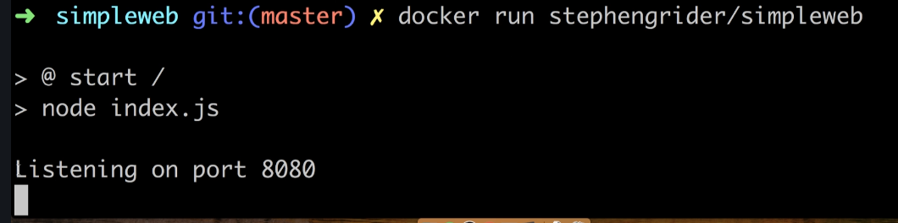

^BUT…he navigated to localhost:8080 and it didn’t work. Why?

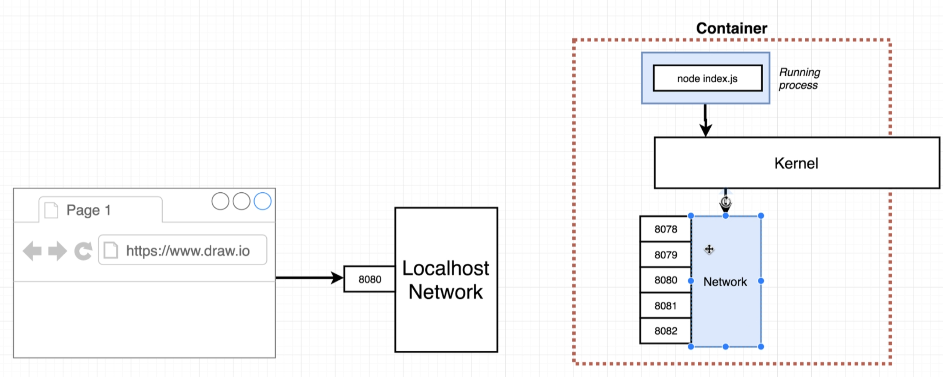

^By default, no traffic that is coming into port 8080 on our local host is being routed to the container. The container essentially has its own isolated set of ports that can receive traffic but currently isn’t. In order to make sure that any traffic either from our computer or another computer, we have to set up a PORT MAPPING. A port mapping makes it so that any time someone makes a request on your local network (i.e. port 8080), take that request and automatically forward it to some port inside the container (any of the open ports inside the container) where our node application can receive and process that request. THIS IS ONLY RELATED TO INCOMING REQUESTS TO THE DOCKER CONTAINER. Our docker container can make requests to the outside world already (this is how it installs the node dependencies).

The port forwarding is not set up inside the dockerfile. It is strictly a run-time constraint (i.e. it’s something we only change when we go to run a container). To set up docker run with port mapping, we use the -p option:

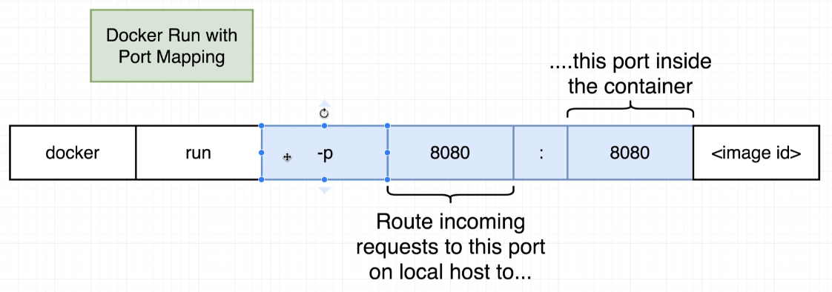



Now the app works successfully. Note: the 2 ports you map don’t have to be the same numbers. If you change the port inside the docker container, make sure your node app in index.js is listening on that port.

Looking into working directories:

Looking at the files and directories inside the container that we have running:

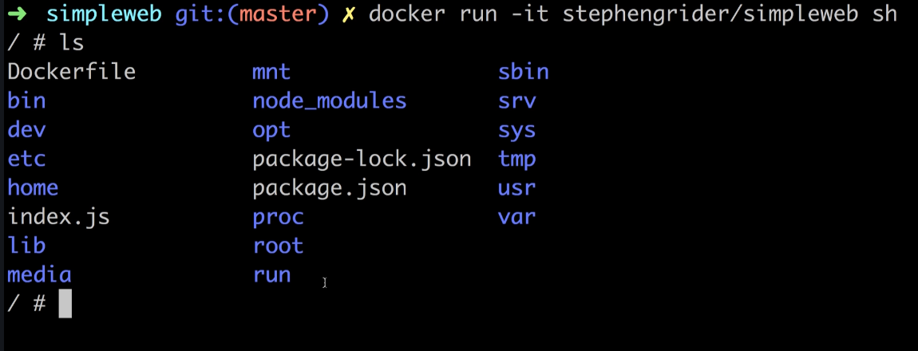

^He could have used the docker exec command with the -it option here and sh to start up a second process inside a running container

^we notice that the COPY command in the dockerfile that we used to make this container copied package.json and index.js into the root directory of this container’s filesystem. Also, the results of running npm install (node_modules folder and package-lock.json) are in our root directory. This is not best practice because we may overwrite folder that are inside of our container (for example, if we were copying a lib directory…which is a common thing to do… the lib directory here would be overwritten). Instead of specifying in the COPY command which directory we want, there is a special command that we can use to address this issue called WORKDIR:

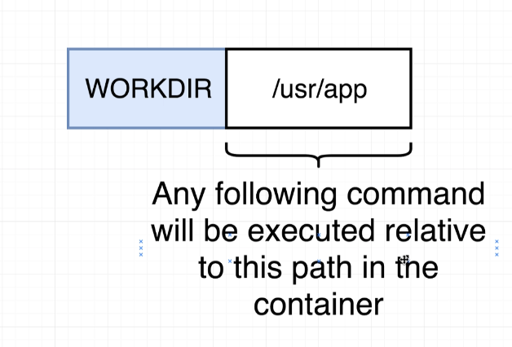

Note: If we specify a folder that doesn’t exist, it will automatically be created for us.

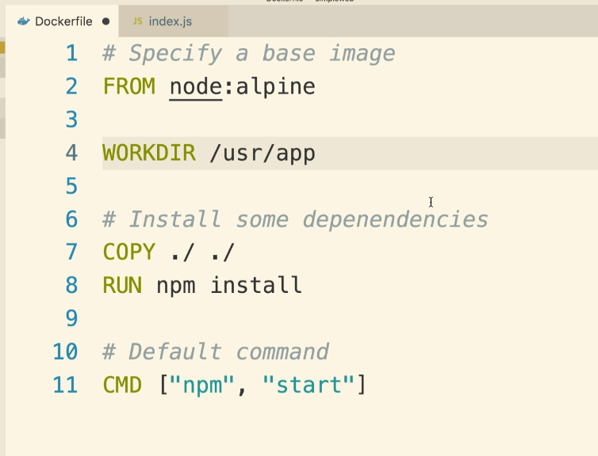

He rebuilt the container with:



And then:



And then to check the directories in this container, he started up a second process, a shell process, in the running container:

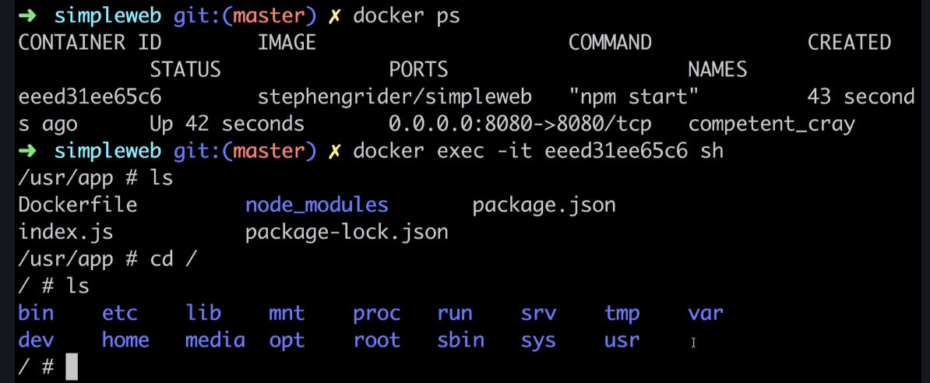

^The shell automatically puts us in the working directory that we specified

Unneccessary Rebuilds: If we make a change to a file, say index.js, and want to see that change take effect, we need to rebuild the image (or use hot reloading, which we will learn about later) and run a new container. Up to the point in the docker file where we have made the change it will run cached versions of the image, but everything after the command with the change (in our example here, COPY ./ ./ and everything after it) would need rerun. Meaning, we would have to re-install all of our node dependencies. To fix this, we can separate our copy steps into two. The first copy can just be the package.json file which npm install needs. The second one will run after npm install (so that it can used the cached version up to this point and won’t need to reinstall dependencies) and will be everything else. Now, only time npm install will need run again is if we make a change to our package.json file (or adding options to the npm install command itself).

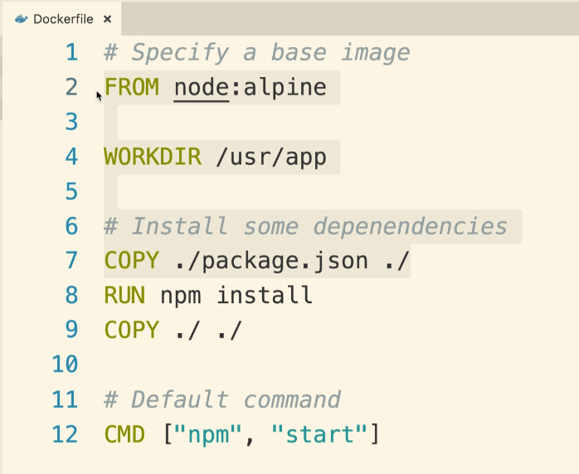



^And now if we have changes to index.js, future builds can use caches up until second copy command and be much faster.

**Section 5: Docker Compose with Multiple Local Containers**

Goal: Make a docker container that displays inside the browser how many times this app has been visited. Instead of storing the number in the node app itself, we want to use a redis database server.

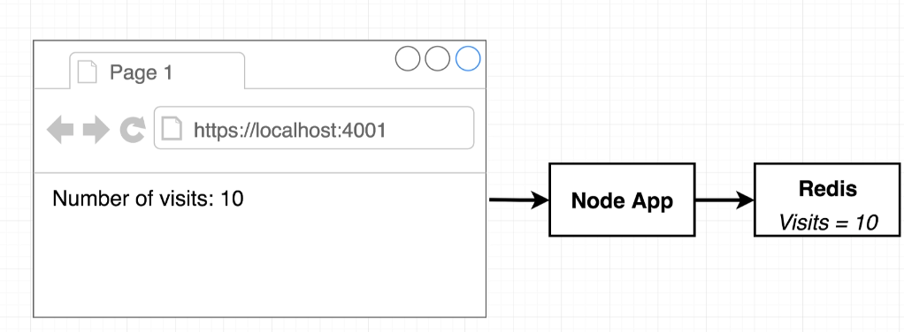

Our first guess may be that we will run our Node App and Redis server in the same container. This is possible but if the app gets a lot of traffic, we will need more web application servers to respond to incoming HTTP requests. So in order to make more servers, we will make more containers. The issue with this approach is that each of these redis database servers would be completely disconnected from one another, so it would respond with a different number for our app depending on which container’s redis database server was responding to that request.

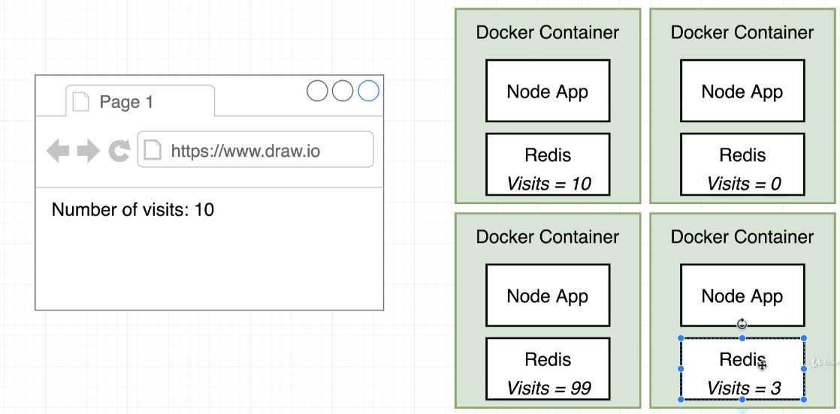

Instead, we should make one single instance of our redis server and then if we need to scale up the web app itself, we can using containers with just the node app. So something like this:

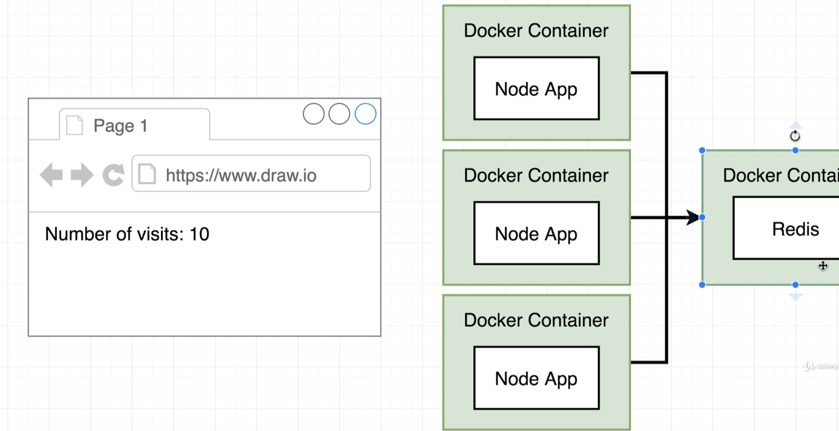

For our project, we will first make one container with our node app and another container with our redis server.

Making the node app in a container:

He made a package.json file:

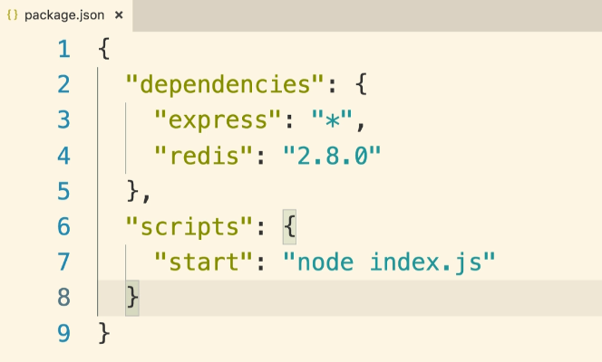

He made an index.js file:

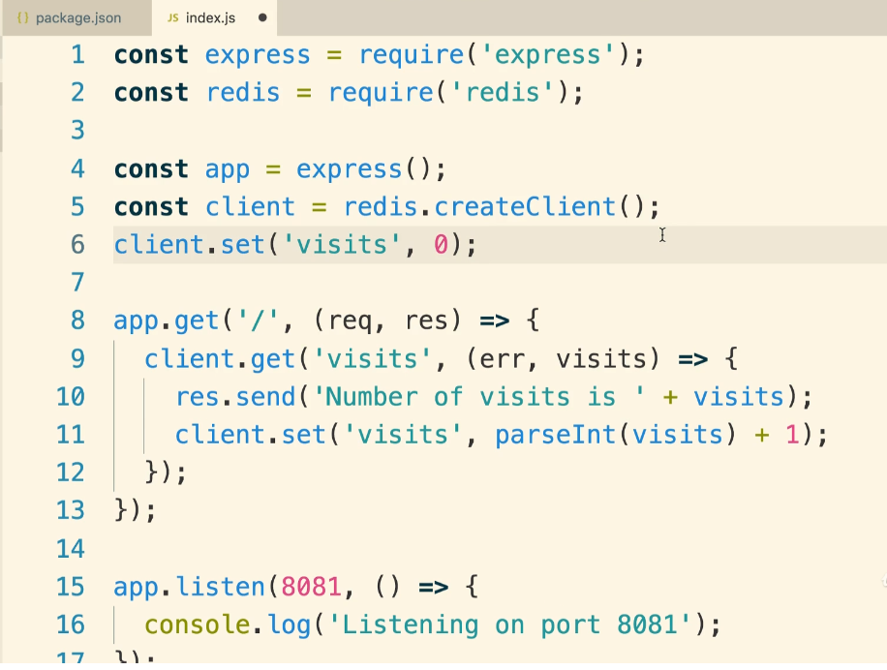

He made a docker file:

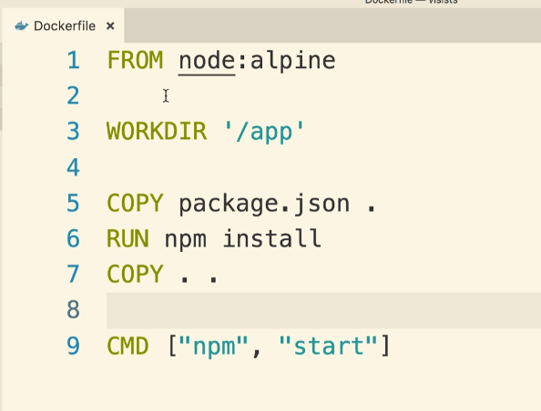



^He instead ran “docker build -t stephenarider/visits:latest” in order to tag it

To run this container:



^should say visits at the end, it got cut off. Could specify :latest at end as well if we wanted but not required.

^This throws an error complaining about how it can’t find a redis server to connect to

The redis server in a container:



^Reaches out to docker hub and runs a container with redis on our local machine. We won’t be doing any customization to it, just using this.

Now, with the redis server running in a separate container, let’s try running the node container in a second terminal:



^Gives same error message because the containers are isolated and need connected.

With what we currently know, we have 2 options for connecting these containers:

1. Use docker CLI’s Network features (this would be annoying because these commands/CLI options would need run anytime we start up a new container)…no one does this in the real world
2. Use docker compose

Docker compose is a separate CLI tool that comes pre-installed with docker:

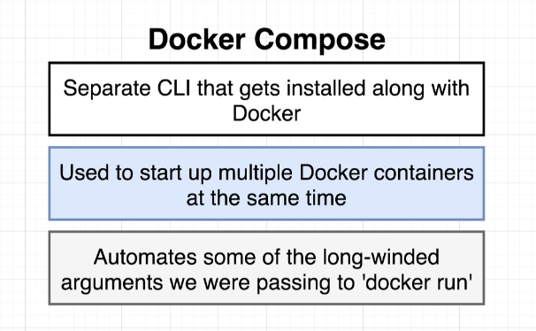

^The big purpose of docker compose is to not only automate some of these long-winded commands, it is to also allow us to start up multiple docker containers at the same time and also connect them to one another.

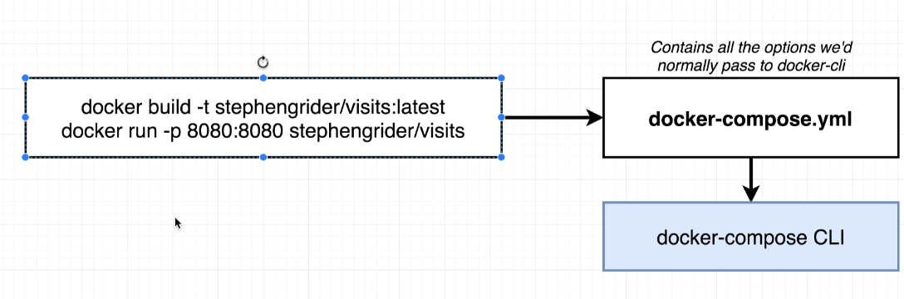

^We will essentially take the same commands that we were running before but encode them in a special syntax into a yml (“yammle”) file. The Docker CLI will then read this yml file and create the containers

Making a Docker compose file:

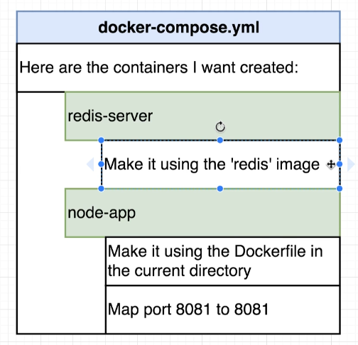

^Map some ports from our local machine to our container so that we can access everything running inside the container

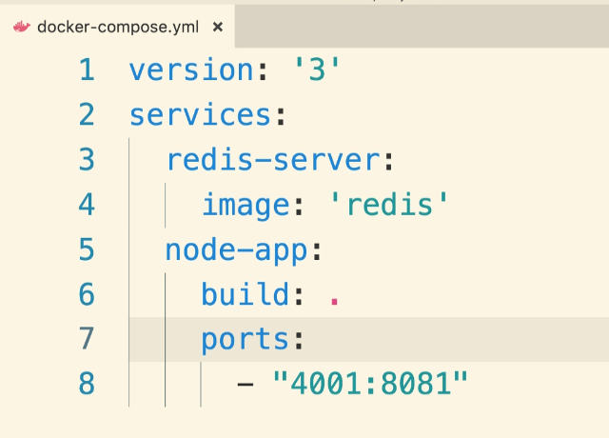

^“Services:” is essentially saying a type of container. For the node app, instead of specifying a pre-built image, we want to build it ourselves using our dockerfile in the same directory

^port 4001 is a port on our local machine and 8081 is the containers port

^DOCKER COMPOSE AUTOMATICALLY CREATES THESE TWO CONTAINERS ON THE SAME NETWORK AND THEY WILL HAVE FREE ACCESS TO ONE ANOTHER. This is done automatically and one of the main reasons for using docker compose. That all happens under the hood. That’s great, but what if we wanted to access the redis server container from the node js app container? We can specify the connection being made in the index js file when we create the redis client:

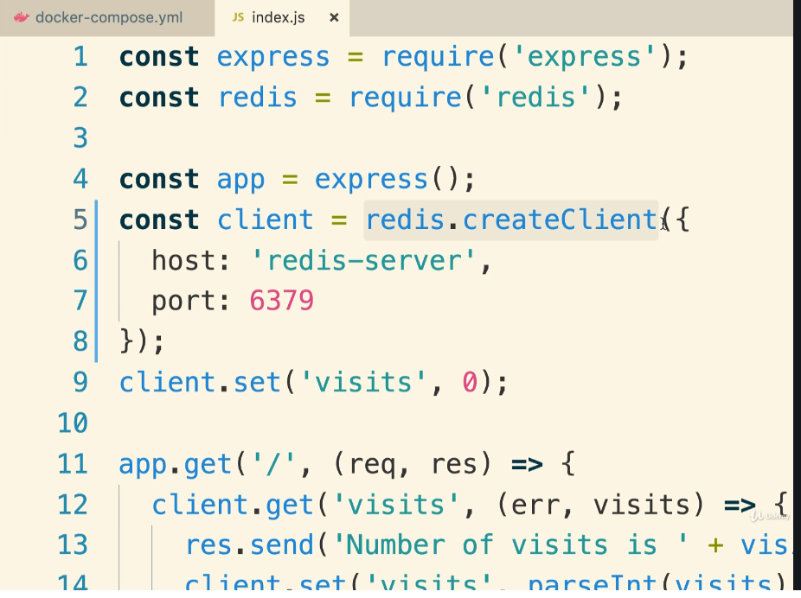

^If we weren’t using docker, the thing inside the curly braces here would be some <http://someaddress.com> …but instead, here we just refer to it as the name that we called it in the yml file. The redis client for our nodejs app has no idea what this is but it makes a good faith effort to try to connect to this host and when it tries, docker will see that request and redirect it to the correct container since it knows what that means.

So again, A MAIN PURPOSES OF USING DOCKER COMPOSE IS TO MAKE IT EASIER TO RUN ALL OF THE COMMANDS THAT YOU’D USUALLY RUN BY USING DOCKER RUN (and it also makes it easier to work with multiple containers connecting to one another)……instead of all these docker run statements, we just list what we want running in the yml file and then run

docker-compose up (and don’t have to specify an image):

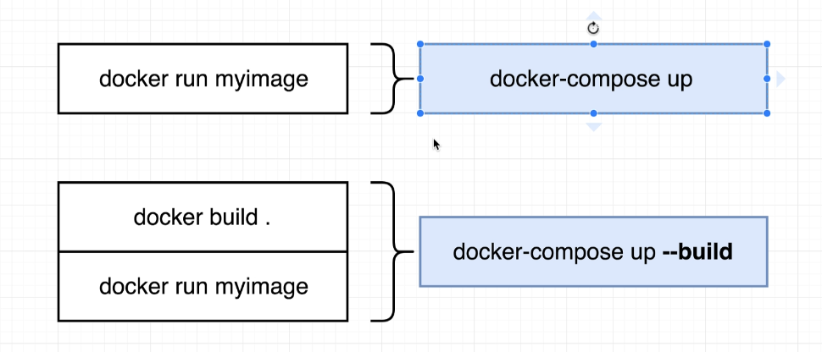

^So if we need to build or rebuild the image, we use the --build option

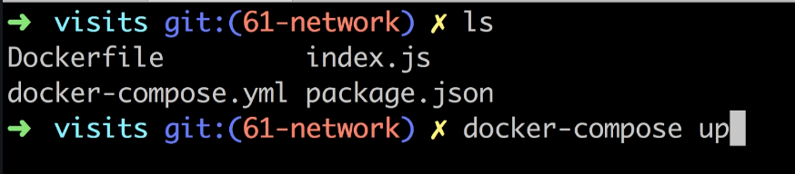

Then he went to his local host and the “Number of visits” page counter worked successfully.

To run and stop a redis container without using docker compose:

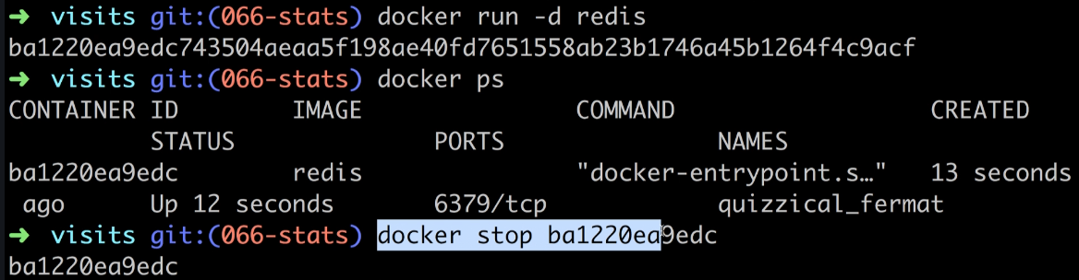

^Note: the -d option runs it in the background

If using docker compose, to stop containers we don’t need to use docker stop. It’s equivalent function to stop all containers that it has up is docker-compose down:

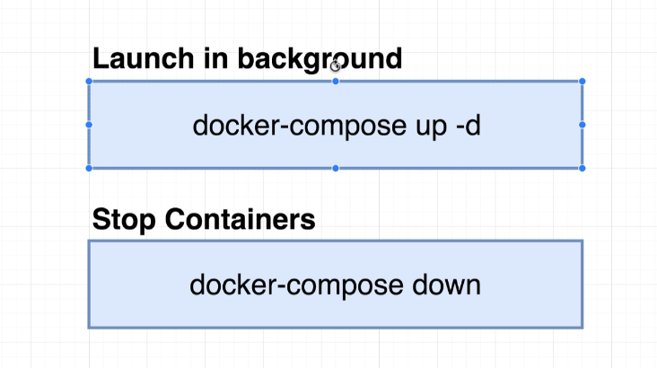

What about crashing containers? How do we restart the container when there is a bug in our app code that causes the container to crash?

He added a bug to the index.js file when we visit the root (/) route. Since he made a change to the code, he needed the --build flag to rebuild the container.



Next he visited the local host and the node container crashed. It only had the redis server still running:

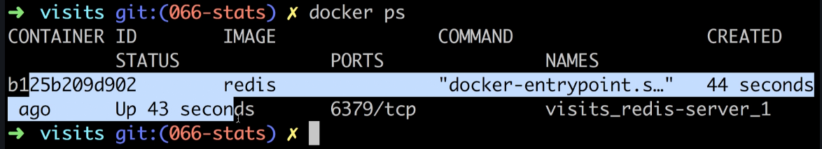

Side note:

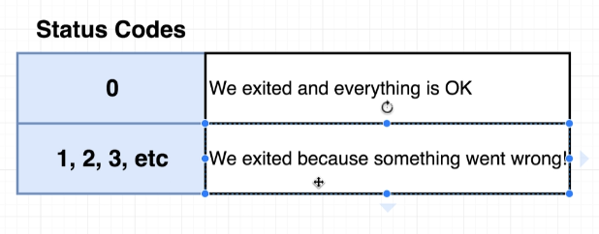

Side note: his addition to index.js was line 13:

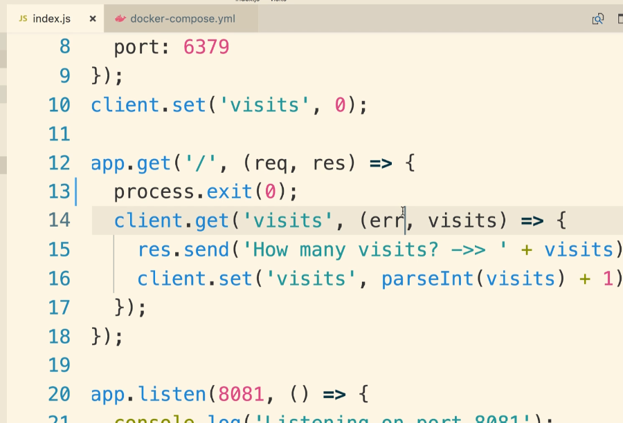

The status code of 0 indicates that we exited because we wanted to…everything is okay and we meant to stop that running process. Any other number is a true error occurred. This is important because it will determine whether docker decides to restart the container.

To perform these automatic container restarts, we need something called a Restart Policy inside of our docker-compose file:

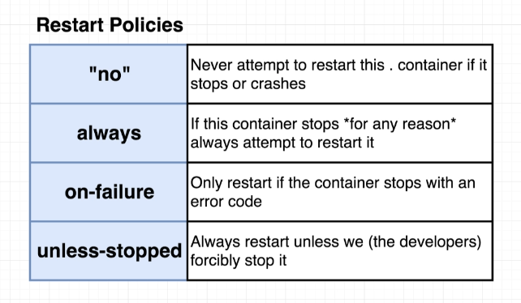

To include this, he added line 6 to our docker-compose file. This is specifically for the node-app container. If we wanted one on the redis-server container we’d have to add it:

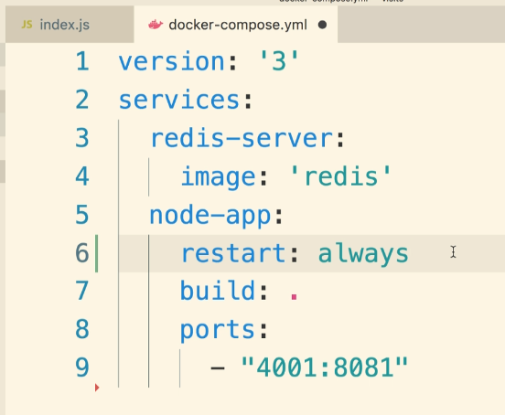

^Side note: If we wanted the “no” restart policy, it needs to be in double or single quotes because the yml file considers no as a boolean false

He said if we our container is running a web server, we should use the always restart policy.  
He said for a worker container that has a job to do and then exits, we’d want to use the on-failure policy because when the worker container finishes its job it does not need to be restarted. Just let it die.

To list the statuses of running containers for docker-compose, instead of docker ps we’d use docker-compose ps:

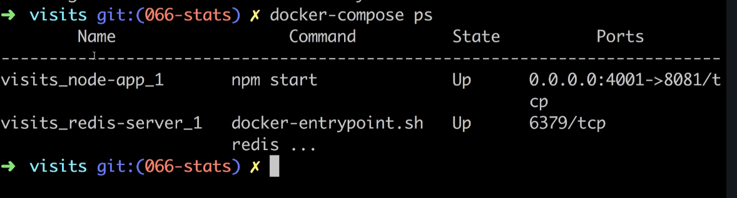

Note: docker-compose ps must be in the same directory as docker-compose.yml

In fact, running docker ps in the same directory as a docker-compose.yml file will force docker ps to list running containers for docker-compose.

**Section 6: Creating a Production-Grade Workflow**

Up til this point, we still don’t know how to use Docker in a production environment. In other words, how do we actually develop an app that uses Docker and then push it to some outside hosting service like AWS or DigitalOcean.

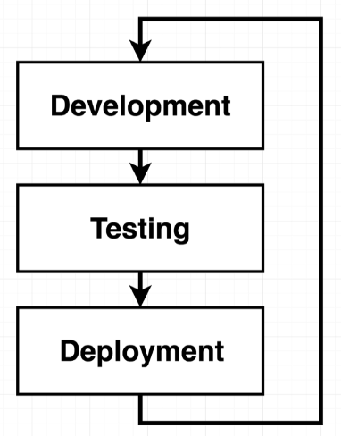

Before adding in the Docker element, let’s just go over the flow of technologies he wants to use in production.

We will use GitHub and have a feature branch for development and a master branch that will be automatically deployed to our hosting provider. We pull code down from the feature branch, make some changes, then push to the feature branch. We will not ever be pushing into master branch directly from our machine…we should only be merging production-ready code to the master branch from the feature branch. This merge from feature to master is actually called a pull request (master branch pulls latest code from feature branch).

To automatically deploy whenever this pull request from feature to master occurs, we are going to set up a CI provider called Travis CI. They pull down your new code and run a set of tests that you specify for your code base to make sure it works. Then it will push to our hosting provider, AWS (AWS Elastic Beanstalk).

We’ll use Docker within these services.

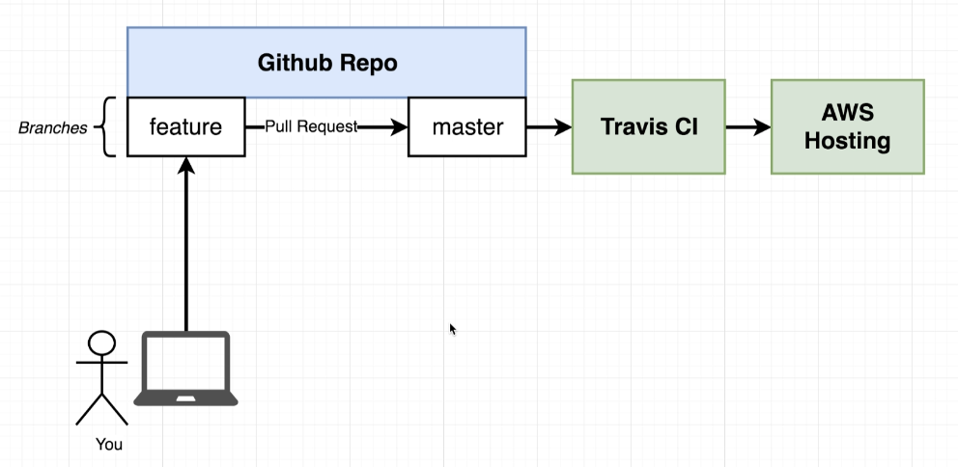

We will be making a react frontend. We will wrap it up inside of a docker container and deploy it.

For creating a react app, as of npm@5.2.0, instead of:

npm install -g create-react-app

create-react-app myapp

Just do this:

npx create-react-app myapp

cd myapp

npm start

Official docs for this are here:

<https://create-react-app.dev/docs/getting-started#quick-start>

Commands we will need while building our react app:

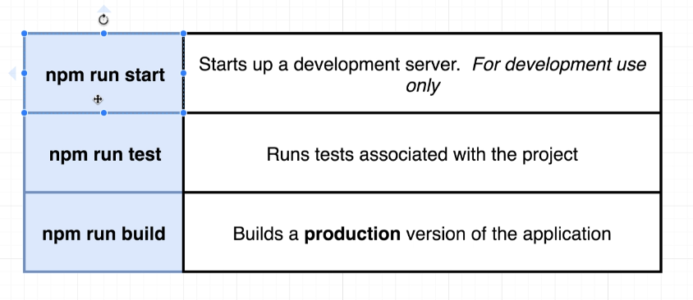

^npm run build is used to take all the of the javascript files into a single file that can then be served in a production environment

We will create two separate Dockerfiles, one for development and the other for the production environment.

Creating the Development Dockerfile, we he called Dockerfile.dev (we’ll need to tell it to look for this instead of just Dockerfile):

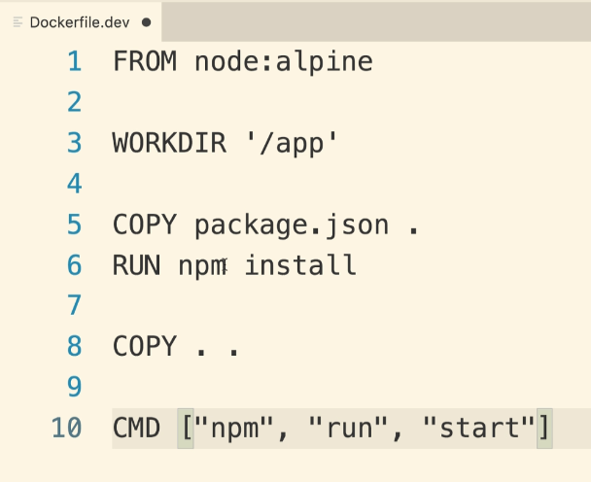

^reminder: COPY . . will copy everything in the current directory that this dockerfile is in on our local machine into the . (which we defined to default to the ‘/app’ directory) on the container

He tried running docker build command and since it was looking for Dockerfile instead of Dockerfile.dev, it returned an error:

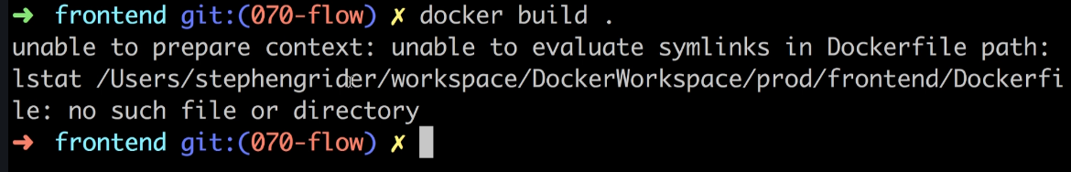

We need this instead:



^Before doing this, we should delete the node_modules folder from our local machine’s react app so that it doesn’t install all of these dependencies twice onto our image (it’s already using package.json file to install dependencies onto our image)

Next, he made a container from this image



But! We forgot to expose a port from our docker container as seen previously in the course. We need the -p option in docker run command:



Now when we navigate to localhost:3000 we see our running react app and it is running inside a docker container! Reminder: this is our development environment, we will make a separate environment for production using a Dockerfile.

DOCKER VOLUMES

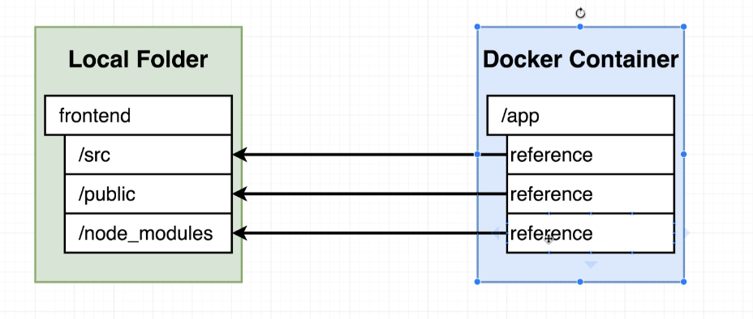

He changed the App.js file which displays our app but in order to see any changes, as far as we know thus far in the course, we’d need to rebuild the image. Let’s find out how to make it so that updating files on our local machine updates them in a running container automatically. Instead of using the COPY instruction in our Dockerfile, we need to make use of something called Docker Volumes. The volume is going to set up a reference on the container’s filesystem that will point back to our local machine, keeping itself up to date.

We set up a Docker Volume by specifying code in our docker run command:

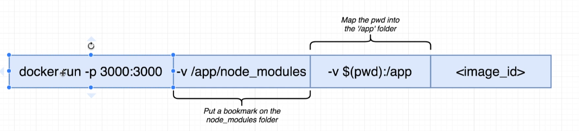

^it has -v $(pwd):/app which will map our current directory on our local machine to /app folder on our container

^the -v /app/node_modules is needed because -v $(pwd):/app is telling it to link everything in our local current directory to the container’s app folder and our local current directory does not have a node_modules folder. So even though our current container has node_modules, it will get overwritten when it tries to look into our local current directory and doesn’t find a node_modules folder. This option makes it so that /app/node_modules does not try to map back to anything inside of our local current. It saves it from being overwritten. This is the functionality of -v option without a colon in the argument. We deleted the local current directory’s node_modules folder previously because when we were using our COPY command in our Dockerfile, we didn’t want to have two sets of the same dependencies (after COPY package.json/npm install and also COPY . .).



That’s a long docker run command. Remember Docker-compose? This was supposed prevent us from making these long docker run commands. Docker-compose can help us here. Here is the docker-compose file needed to make the port settings and 2 volume specs that we have above:

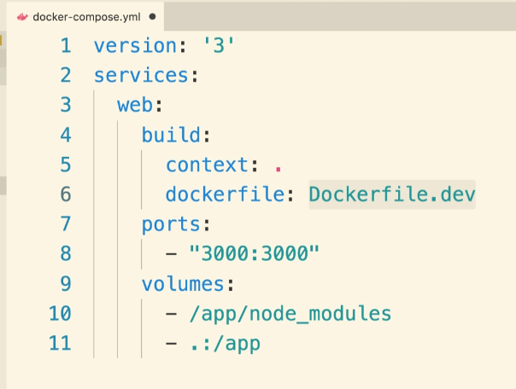

^The build: couldn’t just have build: . because our dockerfile is dockerfile.dev. We needed to specify a “context:” (tells it where all files & folders for this image should be pulled from, so if our project was nested in another folder then we’d have to specify this here) and “dockerfile:”

He then ran docker-compose up to build the image & create the container with our volume configurations in place:



Question we should ask: In our dockerfile.dev which looks like this currently:

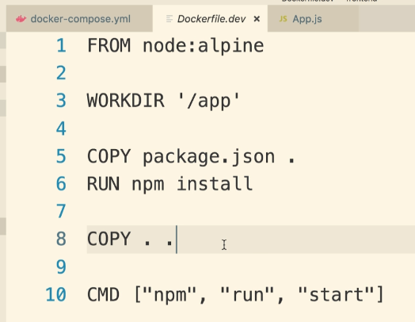

Do we need the COPY . . instruction? Because we are essentially saying copy everything over into the /app directory on our docker container…and with the docker-compose.yml file we made we are saying that everything in the container’s /app directory (except node_modules) should be overwritten by our local machine’s current project directory. WE CAN DELETE THIS COPY INSTRUCTION. HE DECIDED TO KEEP IT BECAUSE WE MAY AT SOME POINT IN THE FUTURE NOT WANT TO USE DOCKER-COMPOSE TO KEEP TRACK OF OUR VOLUME STUFF AND SO IF WE DELETE THE DOCKER-COMPOSE.YML THIS DOCKERFILE.DEV WOULDN’T WORK ANYMORE IF WE DELETED LINE 8 ABOVE. But we still need the COPY instruction on line 5 because we need all of our dependencies (which makes node_modules file).

RUNNING TESTS

Let’s start running tests on our DEV environment, and after that we’ll add using Travis CI for testing.

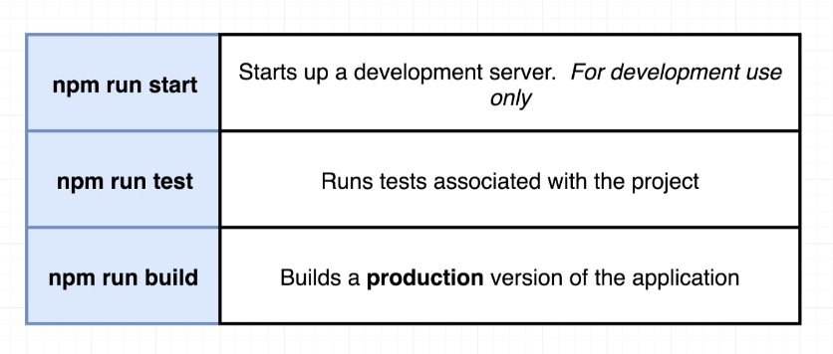

After rebuilding the dev container with:



Reminder: to override the startup command on that container when it starts up, run docker run with the command you want to run after it (here, “npm run test”). NOTE: This ISN’T attaching a second terminal to a running container (That is “docker exec” command):



But we need the -it flags so that it hooks up STDIN/STDOUT to our shell:



This runs tests (our only test is currently defined in src/App.test.js..some default test)

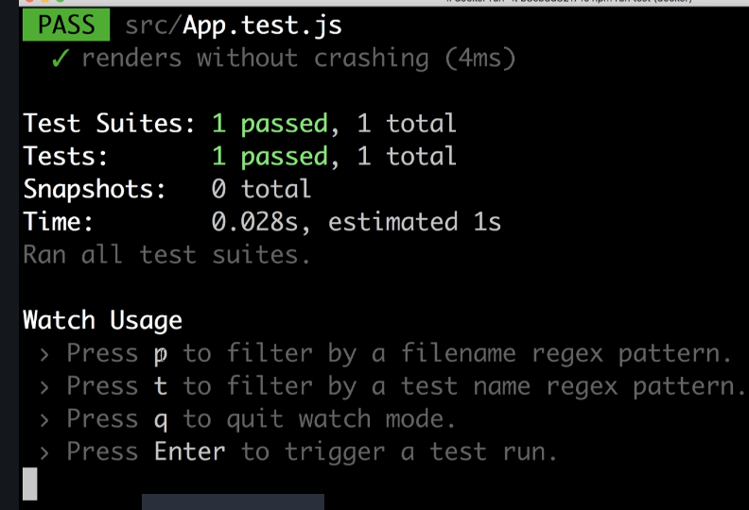

^Hitting “p” allows us to search for a specific test file and run just that test

The App.test.js file currently looks like this and the “it” function is the test currently being run:

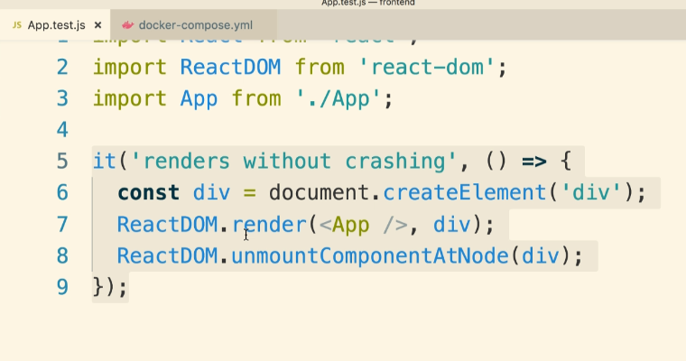

NOTE: Making any changes to this file will not automatically take effect in the container. We would need to rebuild it. This is because we created a separate container with the “docker run <id> npm run test” command and it connected the volumes with either “docker run” with -v options nor “docker-compose up” with docker-compose.yml file configured. So, to make it so that we can make live updates, we can either:

1. Create a docker-compose.yml file that has test services configured inside of it OR
2. Use “docker exec” command to attach a second terminal running inside an already running (volumized) container and run the tests from this attached terminal.

Docker exec way:

First he ran docker-compose up without making changes to the docker-compose.yml file to get a running volumized container. Then ran:



Better solution: add additional service in docker-compose.yml that is solely responsible for running our tests. Our docker-compose.yml previously looked like this:



And he added these lines:

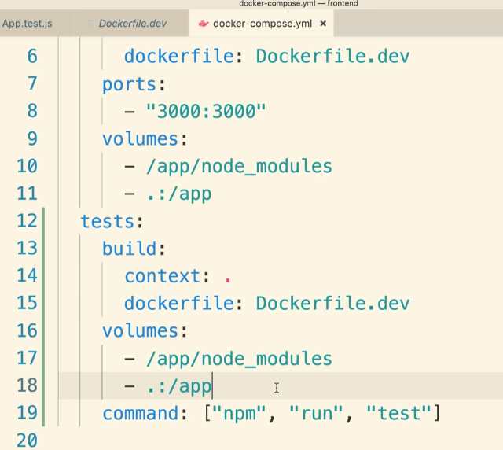

^Note: We do not need to set up ports because our test suite does not make use of any ports…there is really no running server inside this test container.

^“command:” was used to override the startup command

So with this new docker-compose.yml, we start up two containers:

web, which is responsible for hosting our dev server

tests, which is responsible for running our tests and rerunning any time any file inside of our volumes change

NOTE: The downside to live update testing via docker-compose.yml instead of “docker exec -it” is that we don’t have access to our terminal so can’t press any of the options to interact with the testing software such as:

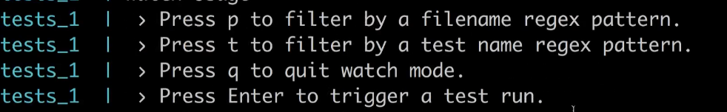

Typically, we can consider using the “docker attach” command, which allows us to attach our local terminal to the STDIN of the *primary* process of a container. However, since the primary process of this container is technically just “npm” itself and npm looks at the “start test” arguments to spawn a secondary process, it doesn’t work in this case as expected. We’d be attaching to STDIN of npm instead of this test process.

Side note: “Docker attach” is easily confused with “docker exec”. “Docker exec” with the option “-it somecommand” runs somecommand as a second command/process inside of an already running container (-it option connects our local terminal with that second process’s STDIN). Docker attach attaches our terminal to a container’s primary process’s STDIN so we have control over that specific process.

**Building Docker Containers in a Production environment**

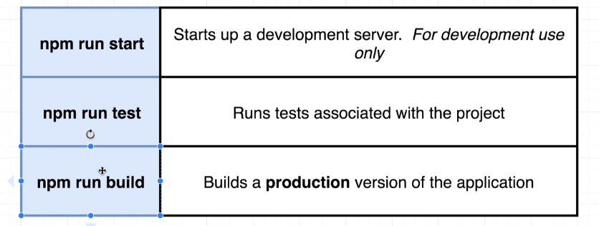

“Npm run build” essentially takes all of your javascript files, processes them all together, makes a single file, and returns it to you in a folder.

In a development environment, we have a dev server handling requests.

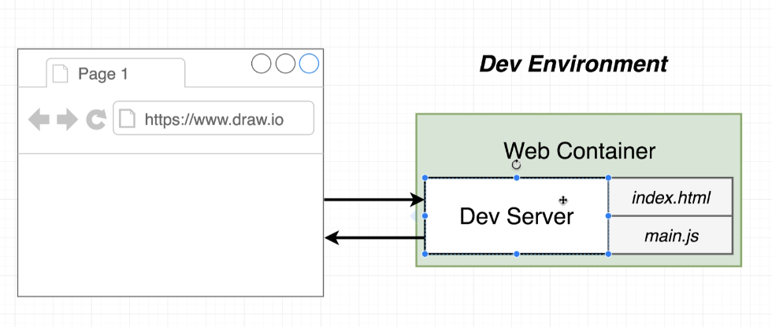

In a production environment we don’t have a dev server. This dev server has a ton of processing power inside of it to solve the logic needed when we were handling requests in our development environment. Now that that complex logic and necessary processing is removed via the production build (where we are just left with html file and javascript file, for example), we no longer need this server. We still need a server but it won’t be as cumbersome. It just needs to take incoming requests and respond with the right files:

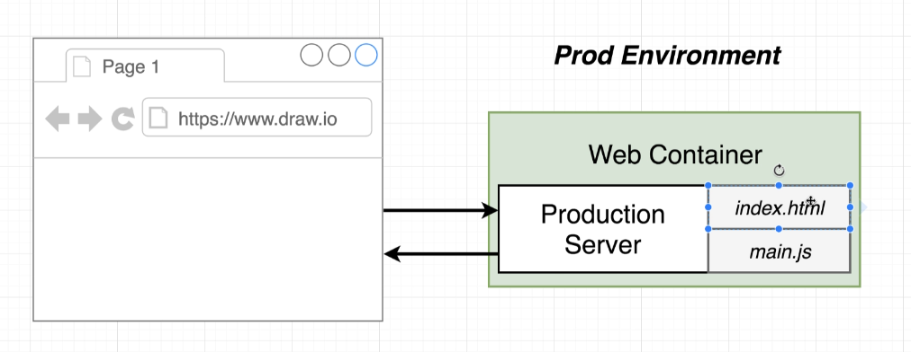

We will be using nginx for our prod server which is a very popular web server which doesn’t have much logic besides taking in and responding to web traffic with some static files.

We will be creating a separate Dockerfile (we’ll call it Dockerfile) which will create a production version of our web container (with nginx, index.html, and main.js).

Here was Dockerfile.dev:

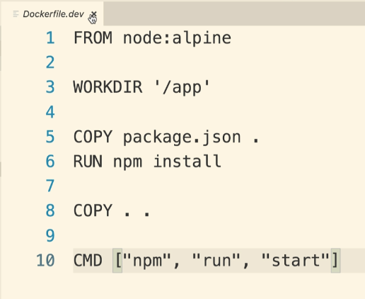

Here’s what we’ll need to do:

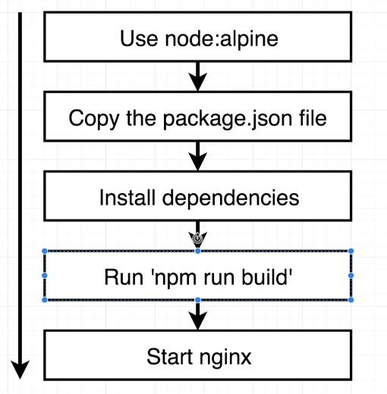

^“npm run build” will create our production assets, after which we will start our nginx server

^NOTE: We will only need to install dependencies tied to what npm run build needs!

**^NOTE: We will need nginx but we can’t use the nginx image because we need the node:alpine image…so we need to use two separate builds (node:alpine and nginx) and combine them.**

So instead:

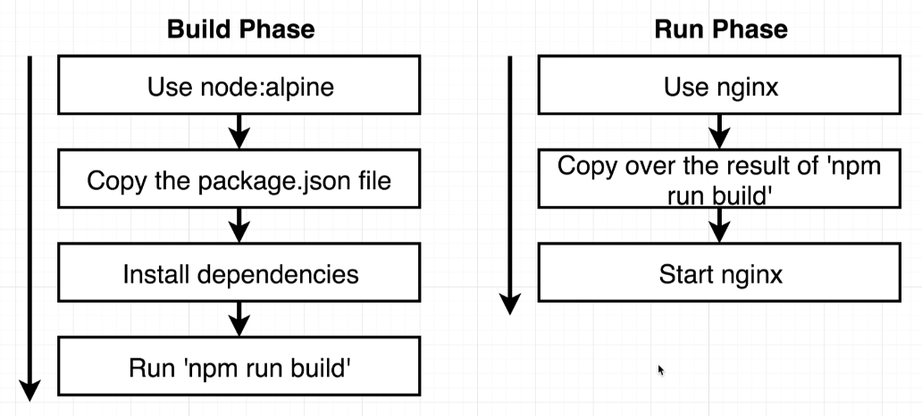

^When we copy over the results of “npm run build” into our nginx image, it’s just the output files (all the exists in the “build” folder)…so it doesn’t need/include the node:alpine image, the dependencies that were installed in order to make the build, etc.

Dockerfile production file:

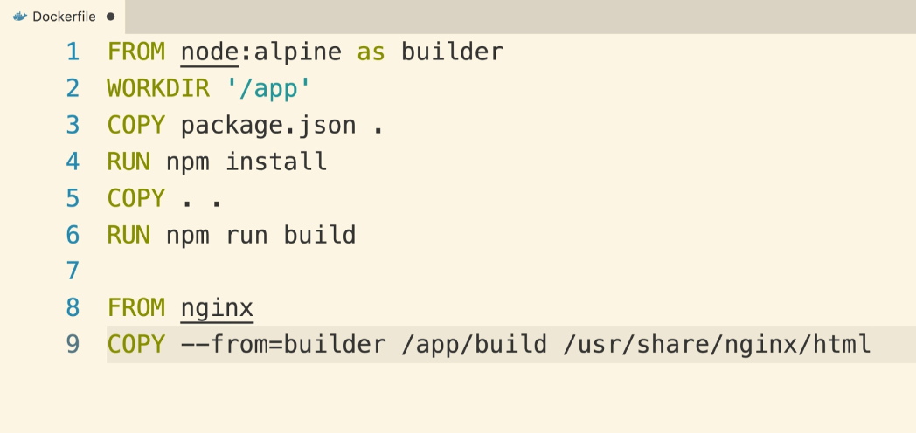

^The default startup command for nginx container is “start nginx”

^The --from option specifies that we want something from a different phase

^The output from the build phase will be in /app/build, so we will want to copy this into a specific folder on our Docker container…we knew where this folder was by looking at the nginx Docker Hub page:

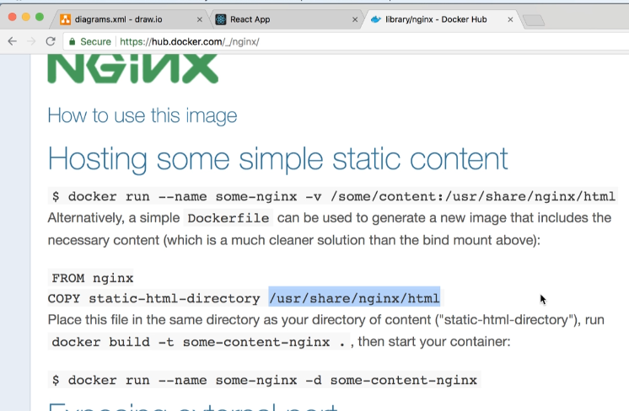

Next, build image:



Next, run container:



^Need to open up ports here because nginx is a web server and it needs access to the traffic. The default port nginx uses is port 80.

And it worked!